D424 – Software Engineering
Task 3
Capstone Proposal Project Name: |   Media Backlog Manager
Student Name: | Aaron Hansen

Table Of Contents
Table Of Contents 2
Application Design 3
Class Design 3
UI Design 4
Unit Test Plan 8
Introduction 8
Purpose 8
Overview 9
Test Plan 10
Items 10
Features 10
Deliverables 10
Tasks 11
Needs 11
Pass/Fail Criteria 12
Specifications 15
Procedures 18
Results 18
Guide for Setting Up and Maintaining the Application 20
Local Environment Setup 20
Backend Setup 20
Frontend Setup 21
Additional Information 22
Deployment Steps 22
Frontend Initial Setup. 22
Backend Initial Setup 25
Final Configuration 28
User Guide 30
Introduction 30
Opening the Application 30
Account Creation 30
Adding an Item to Your Backlog 31
Viewing a Backlog Item 34
Editing a Backlog Item 35
Searching Your Backlog 36
Viewing Backlog Reports 38
Exporting Your Data 39
Logging Out 39

Application Design

Class Design
There are 3 main classes involved in the Media Backlog Manager: User, Media, and UserMedia. The User class was used to store a user’s information and to represent a specific user throughout the application. Media is a base class that stores information shared by derived media classes. The Media class also enables polymorphic data handling throughout the application. Lastly, the UserMedia Class facilitates a many-to-many relationship between User and Media. The UserMedia class stores information specific to a user’s relationship to a piece of media. For example, it stores the user’s consumption status, rating, completion date, and a list of recommenders for each item. 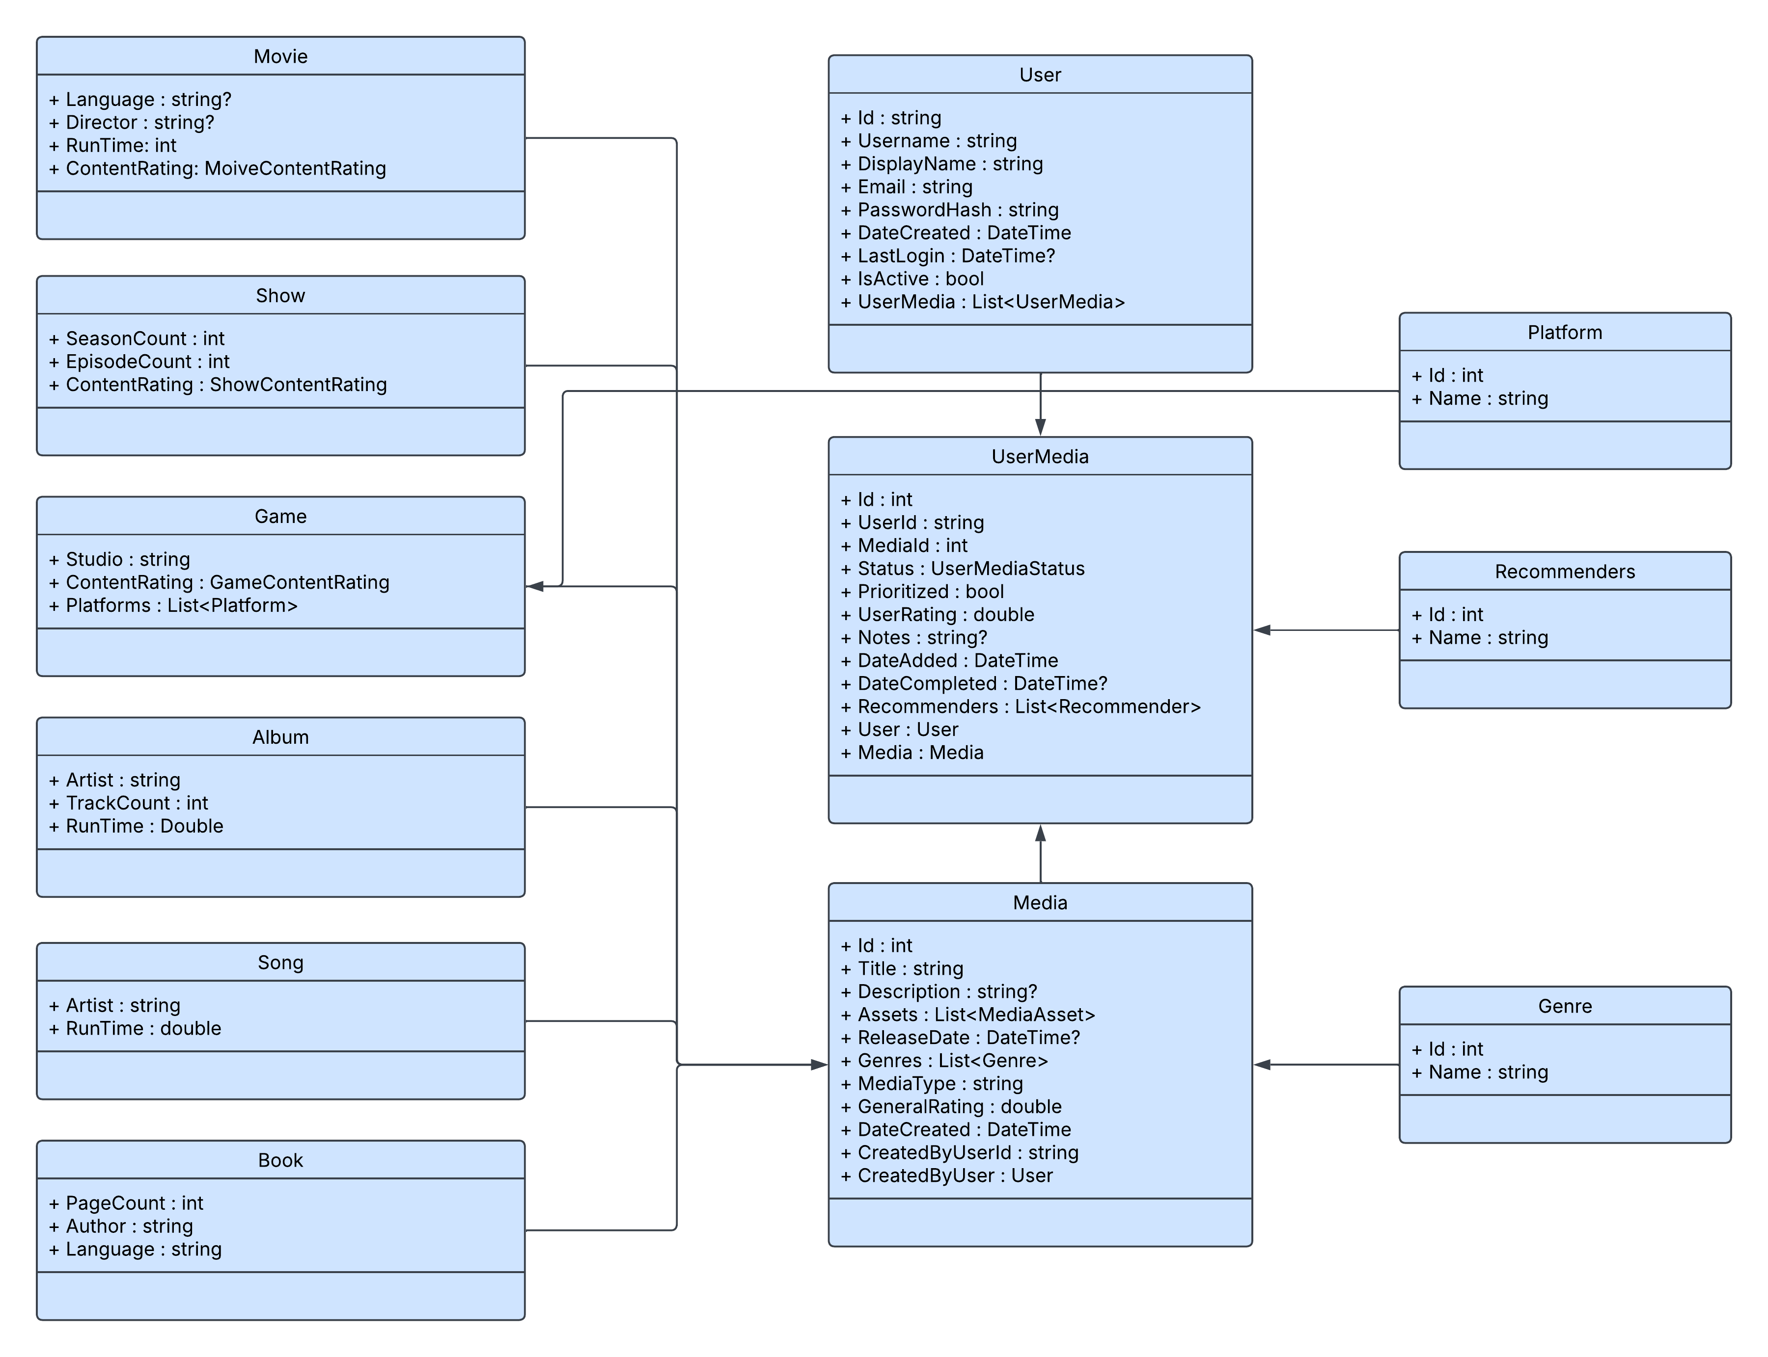
Shown in the center column of the diagram above is the structure of the three main classes that the application works with, along with the derived media classes shown on the left. On the right side of the diagram are additional classes that track specific properties used by the Game class, the Media class, and the UserMedia Class.

UI Design
Shown below are various UI wireframes created early in development. These wireframes show the main pages of the apps. Many additional fields have been added as additional features and fields have been required. The wireframes shown below include the Home page, Media View page, Add Media page, Login Page, Account Creation page, Data Export page, and the Profile Menu.
Home Page
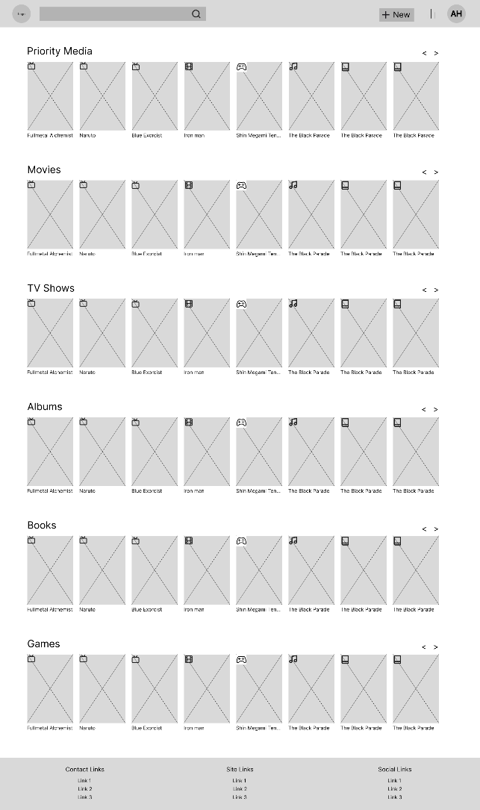
Media View Page
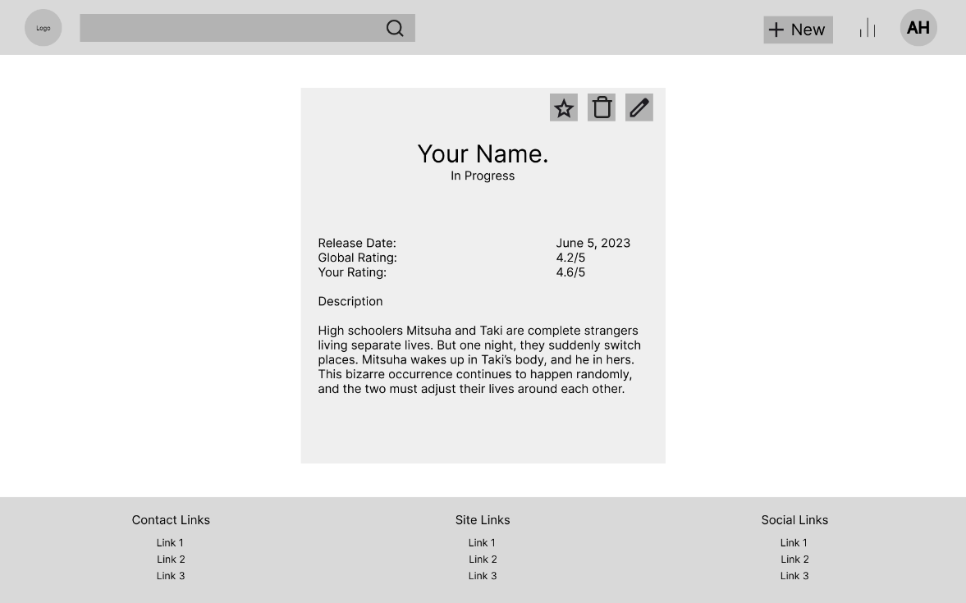
Add Media Page
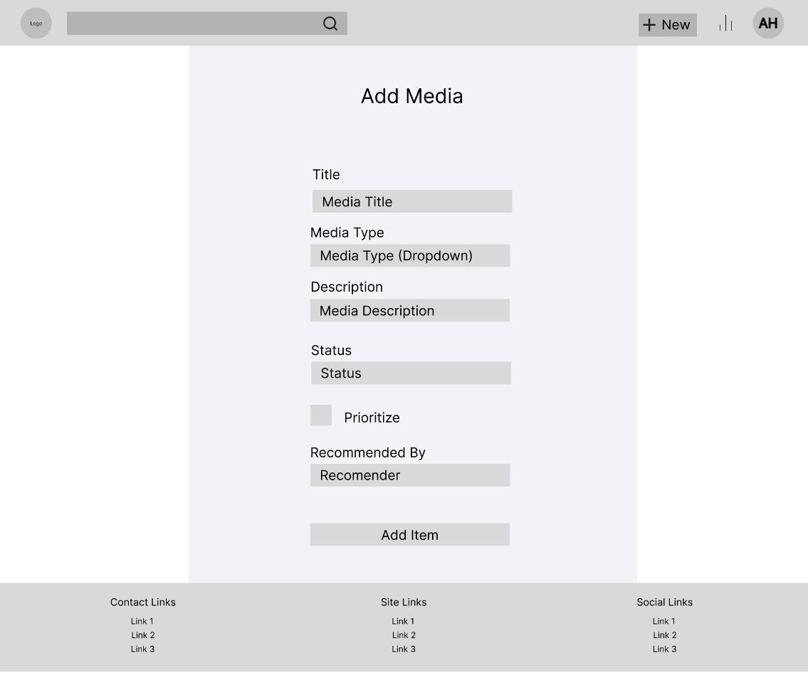

Login Page
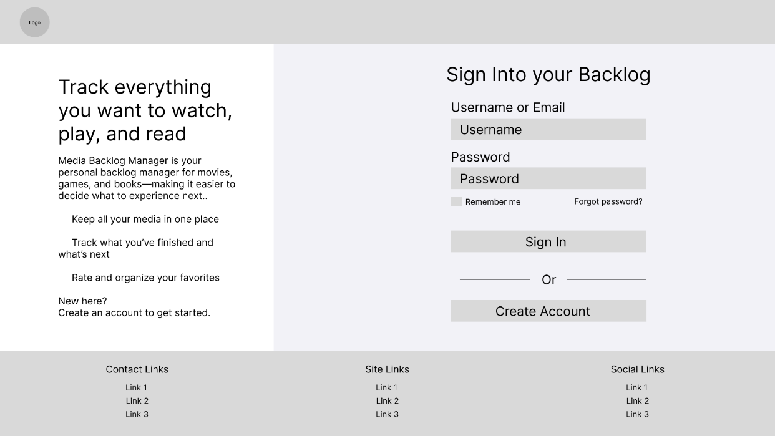
Account Creation Page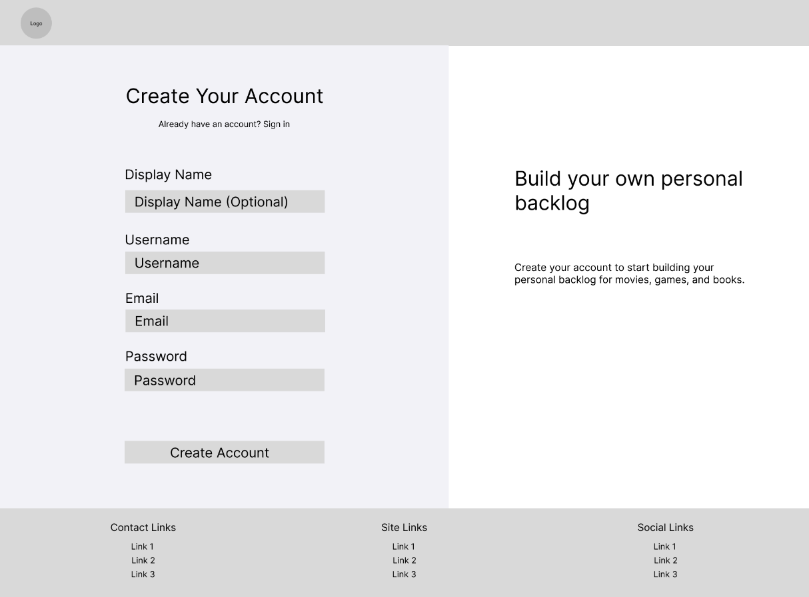

Data Export Page
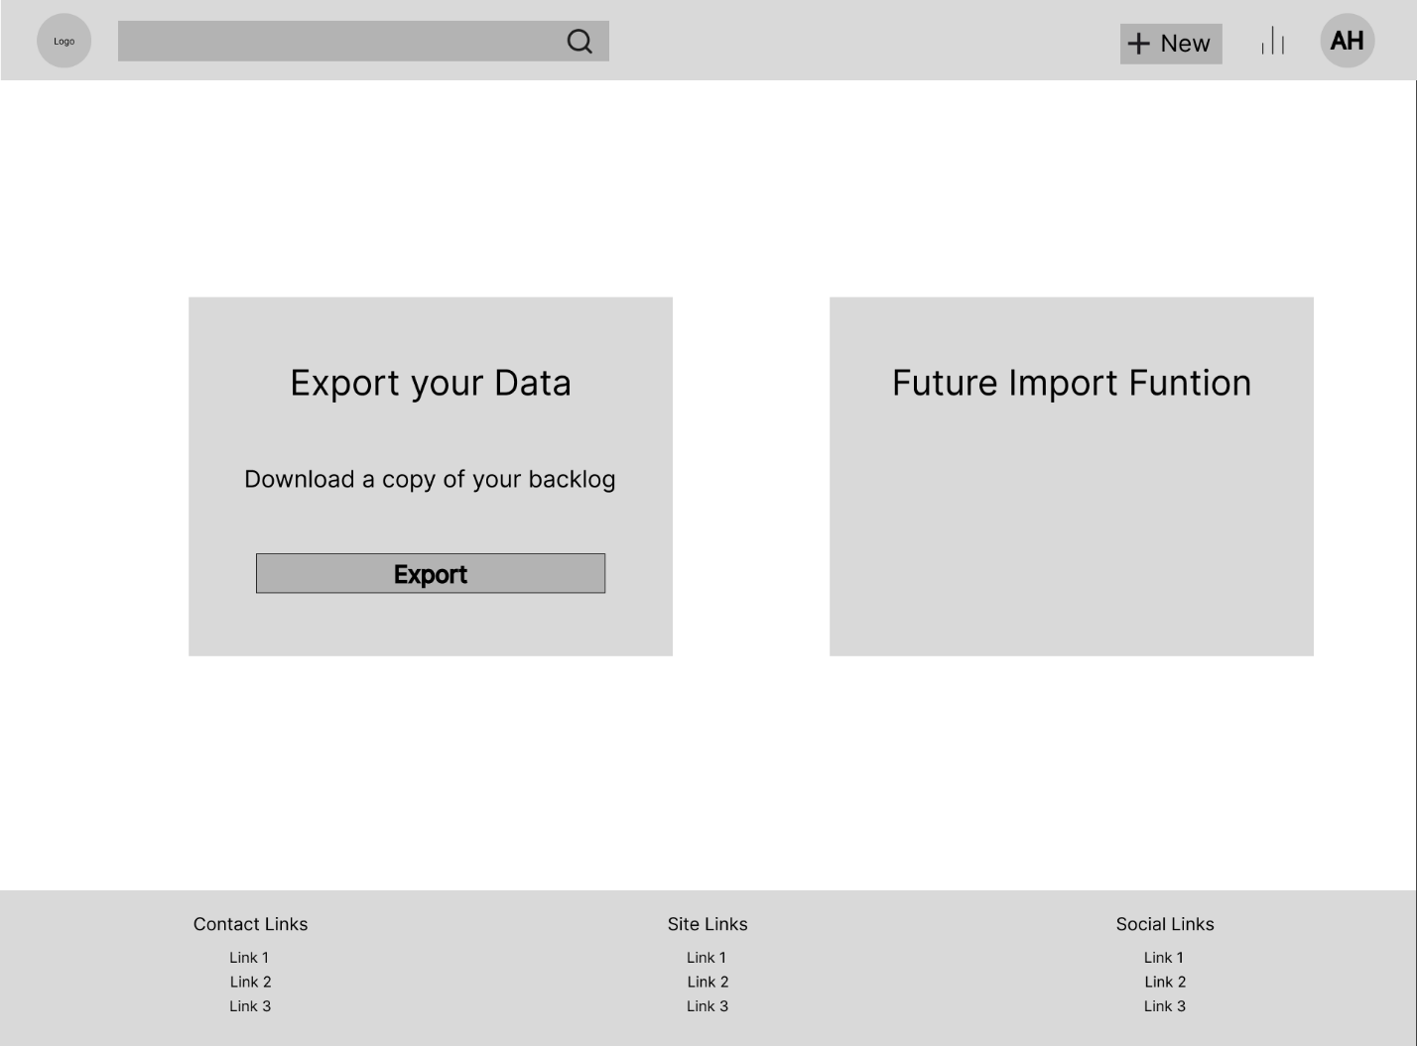
Profile Menu
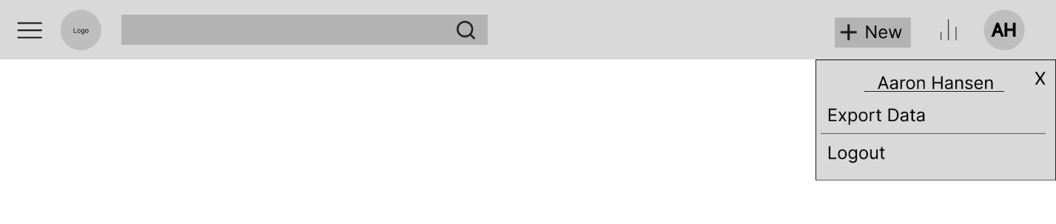

Unit Test Plan

Introduction

Purpose
Various testing methods will be utilized to ensure the application functions as intended. xUnit will be used to perform Unit Testing. Postman will be used to perform integration testing and API Testing. End-to-end testing will be done manually. These tests will be used to ensure that individual units, API endpoints, and application features all behave as expected. When tests fail, root cause analysis will take place, and the root of the issue will be fixed.

Overview
Three main testing methods will be used. First, Unit Testing will be done using xUnit. These unit tests will ensure that individual service methods function as expected, given various inputs. It will also test cases that should fail and ensure that they will fail gracefully. Second, integration testing and API testing will be completed with Postman. Integration testing will ensure that the API controllers interact properly with the application services. Each of the API requests in the collection will be used to test the CRUD operations made available through the API. Further, the Postman tests will be used to test the authentication method built into the application, only allowing requests that bear the proper authentication token to perform actions. Lastly, end-to-end testing will be done manually. These tests will be done to ensure that the frontend communicates with the backend properly. These tests will ensure that any feature behaves properly on the frontend, makes the necessary changes on the backend, or retrieves data correctly.
The test plan below will cover the unit tests performed on the authentication system. These unit tests will be performed as described above. The tests performed on the authentication system are as follows:
- Test the login logic of the application, which allows a user to sign in with a username and password and return an authentication token.
- Test the account creation feature to ensure that a new account can be created properly.
- Test incorrect credential sign-in scenarios.
- Test attempts to create a new account with conflicting information, such as a second account with the same username or email address.
- Test attempts to create a new account with a password that does not meet the password requirements.

Test Plan

Items
The following Items will be needed to perform these tests
- A development environment with the needed .NET development tools installed
- A database will need to be configured in the application to ensure that each test is performed in an empty database.
- A testing framework will be needed so the tests can be composed and run. xUnit has been selected for these unit tests.
- The Application Source Code will be needed as it is the object of the testing

Features
- The authentication system will be the primary feature being tested
- The database system will be a secondary focus in these tests. Because the authentication system needs to store data in the database for authentication, the database will need to be checked for proper storage of the account information.

Deliverables
- Each test will produce a test script. This collection of scripts will be used to perform the unit tests. These tests are available in the GitLab repository.
- Each test will produce test results. These results will be automatically produced by the testing framework and will show the result of each test.

Tasks
- To begin the tests, a suitable development environment will need to be set up. Within this environment, ASP.NET development tools and xUnit must be installed. The dependencies within the ASP.NET project will also need to be installed. These include EntityFrameworkCore, EntityFrameworkCore.InMemory, SQLitePCL, and Microsoft.Identity.
- The Unit tests are set up in a separate project, but within the Visual Studio solution.
- Dependency injection must be manually set up for proper testing of the authentication service, as it is heavily used within the application due to its use of ASP.NET.
- The database must be configured within the application, as it uses an SQLite database. The database will be set up as an in-memory database, which will be completely fresh for each test.
- The unit tests will be executed using the Visual Studio Test Explorer.
- The test results will be analyzed. Any failing tests will be reviewed to identify a root cause. Once a root cause has been identified, it will be corrected, and the tests will be run again.

Needs
- The application’s dependencies as described above must be installed. Any packages that are installed must use the proper versions to avoid any issues.
- The testing framework is needed to frame and run the tests within the Visual Studio Test Explorer.
- The source code must be accessible for use within the tests and to be reviewed and updated as needed based on the test results.
- No test data is needed in the database, as all data is created within the contents of the test.

Pass/Fail Criteria
Register a new User
  - Pass:
    - An AuthResponse object is returned.
    - The AuthResponse object contains a token
    - The AuthResponse object does not contain any errors in its error list
  - Fail:
    - An AuthResponse object is not returned
    - The AuthResponse object does not contain a token
    - The AuthResponse object contains an error in its error list
    - An Error is thrown within the account creation method
Login attempt with correct Credentials.
  - Pass:
    - An AuthResponse object is returned.
    - The AuthResponse object contains a token
    - The AuthResponse object does not contain any errors in its error list
  - Fail:
    - An AuthResponse object is not returned
    - The AuthResponse object does not contain a token
    - The AuthResponse object contains an error in its error list
    - An Error is thrown within the account creation method
Register a new User.
  - Pass:
    - An AuthResponse object is returned.
    - The AuthResponse object contains a token
    - The AuthResponse object does not contain any errors in its error list
  - Fail:
    - An AuthResponse object is not returned
    - The AuthResponse object does not contain a token
    - The AuthResponse object contains an error in its error list
    - An Error is thrown within the account creation method
Login attempt with a blank username and password.
  - Pass:
    - Null is returned
  - Fail:
    - An object of any type is returned
    - An Error is thrown within the login method
Attempted account creation with a duplicate username.
  - Pass:
    - An AuthResponse object is returned.
    - The AuthResponse object does not contain a token
    - The AuthResponse object contains errors in its error list
    - The error list contains the duplicate username error message
  - Fail:
    - An AuthResponse object is not returned
    - The AuthResponse object contains a token
    - The AuthResponse object does not contain an error in its error list
    - The error list does not contain the duplicate username error message
Attempted account creation with a duplicate email address.
  - Pass:
    - An AuthResponse object is returned.
    - The AuthResponse object does not contain a token
    - The AuthResponse object contains errors in its error list
    - The error list contains the duplicate email error message
  - Fail:
    - An AuthResponse object is not returned
    - The AuthResponse object contains a token
    - The AuthResponse object does not contain an error in its error list
    - The error list does not contain the duplicate email error message
Attempt to create a new user with a blank password or a password that does not meet the password requirements.
  - Pass:
    - An AuthResponse object is returned.
    - The AuthResponse object does not contain a token
    - The AuthResponse object contains errors in its error list (The message that is returned can vary depending on what part of the password requirements the password does not meet; therefore, the message contents are not checked)
  - Fail:
    - An AuthResponse object is not returned
    - The AuthResponse object contains a token
    - The AuthResponse object does not contain an error in its error list

Specifications
Below are screenshots of the unit test scripts that have been described above. Each unit test method begins with an initial setup that creates the User Group that the application uses, as well as a user to test login methods and conflicting account creations.
Initial Setup Method – This will be used in every other unit test. 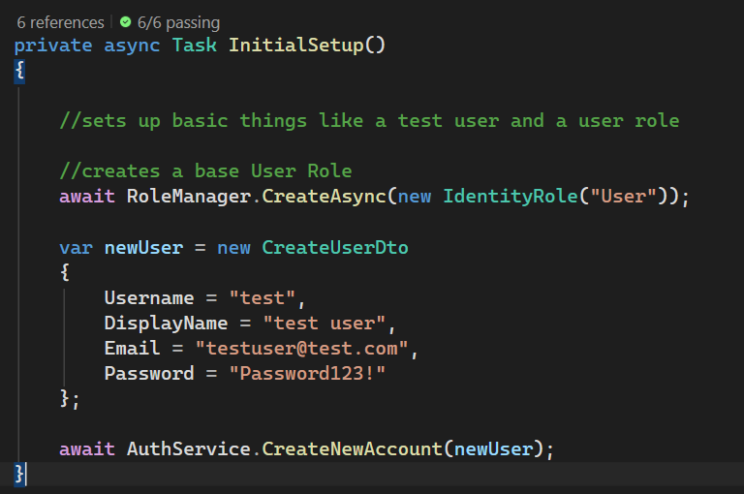 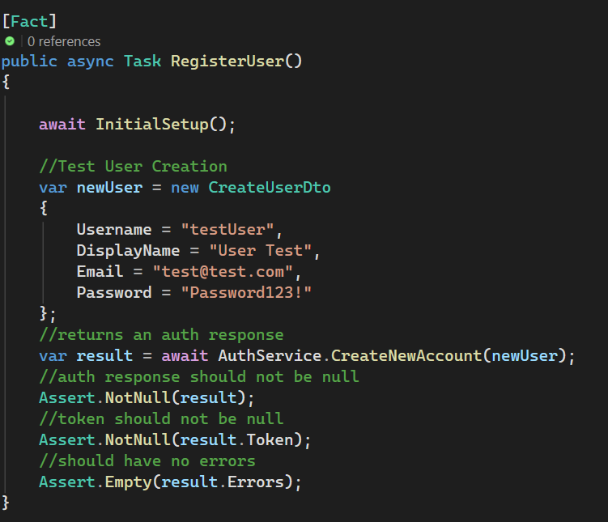
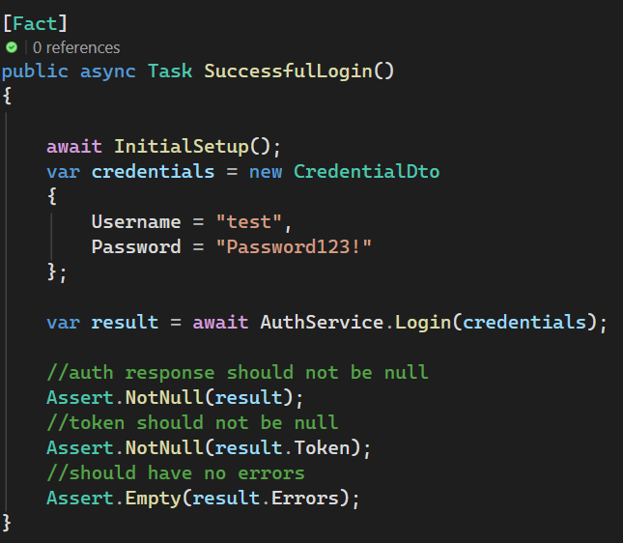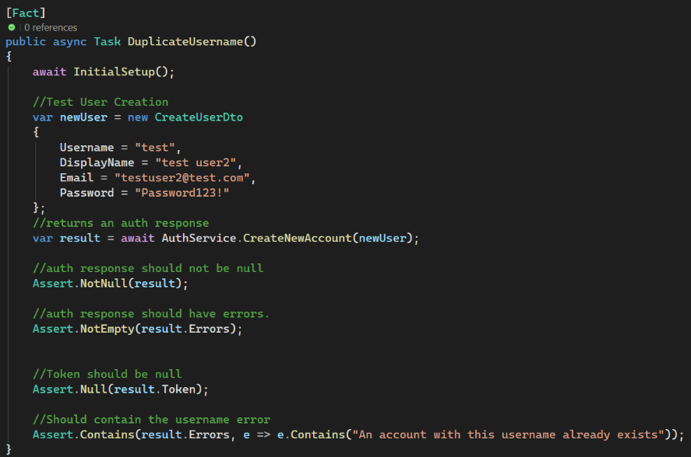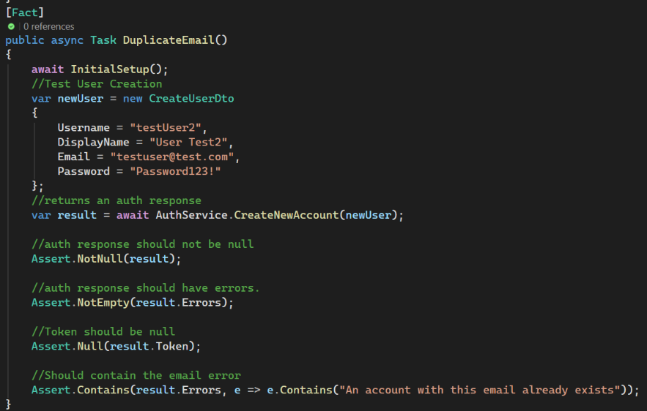
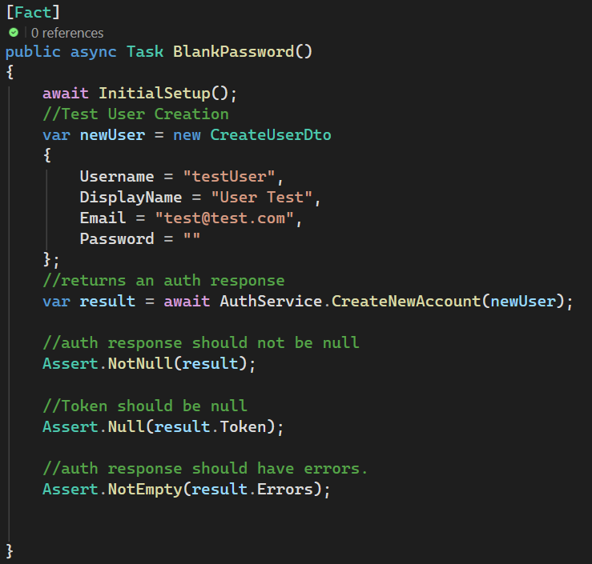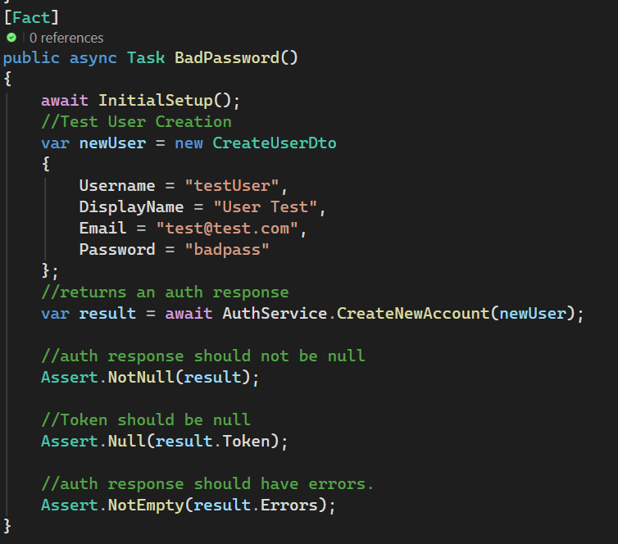

Procedures
Identify features to test – In order to write the unit tests and prepare the testing environment, the features that need to be tested must be identified.
Set up the test environment - The test project must be created, and the dependency injection must be set up to accommodate the feature’s reliance on dependency injection. This dependency injection setup will make writing and configuring the tests much faster.
Set up the unit tests – The scripts must be written for the unit test. Each test will test a particular feature or aspect of the feature. They must be written to avoid any conflicts with any other unit tests.
Execute the unit tests – The tests will be executed using the test explorer in Visual Studio. These tests will all run individually and should run in a way that avoids conflicting with any other unit tests.
Analyze the results – Once the tests have been run, the results must be analyzed. If a test fails, it must be analyzed to find a root cause analysis for the test failure. If the test fails due to a bug in the test logic, then the logic will be corrected, and the test will be run again. If the test fails due to an issue in the feature’s logic, then the cause will be identified, and a solution will be designed and implemented. Once the fix has been implemented, the application will be tested again before considering the test passed.

Results
The results for the tests were obtained after executing the unit tests as described above in the procedures section. Detailed below are the results of each test in the order shown in the screenshot at the end of this section.
BadPassword – This test is to ensure that an account creation with a “bad password” or a password that does not meet the password requirements does not succeed. This test passed, as an AuthResponse object was returned to the caller. The AuthResponse object did not contain any authentication token but did contain errors in the object’s error list.
BlankLogin – This test is run to ensure that a login attempt with no credentials does not cause any issues, and the user is unable to log in. This Test passed, as null was returned to the caller as required by the test pass requirements as outlined above.
BlankPassword - This test is to ensure that an account creation with no password does not succeed. This test passed, as an AuthResponse object was returned to the caller. The AuthResponse object did not contain any authentication token but did contain errors in the object’s error list.
DuplicateEmail – This test is to ensure that an account cannot be created that has the same email address as another account. This test passed, as an AuthResponse object was returned to the caller. The AuthResponse object did not have an authorization token but did contain the necessary error notifying the caller of an email conflict.
DuplicateUsername – This test is to ensure that an account cannot be created that has the same username as another account. This test passed, as an AuthResponse object was returned to the caller. The AuthResponse object did not have an authorization token but did contain the necessary error notifying the caller of a username conflict.
RegisterUser – This test is to ensure that the user registration method functions as expected, allowing a new user to create an account and receive an authorization token. The test passed as the method returned an AuthResponse object that contained the proper authorization token and did not contain any errors in the object’s error list.
SuccessfulLogin - This test is to ensure that a user is able to log in with proper credentials as expected and receive an authorization token. The test passed as the method returned an AuthResponse object that contained the proper authorization token and did not contain any errors in the object’s error list.

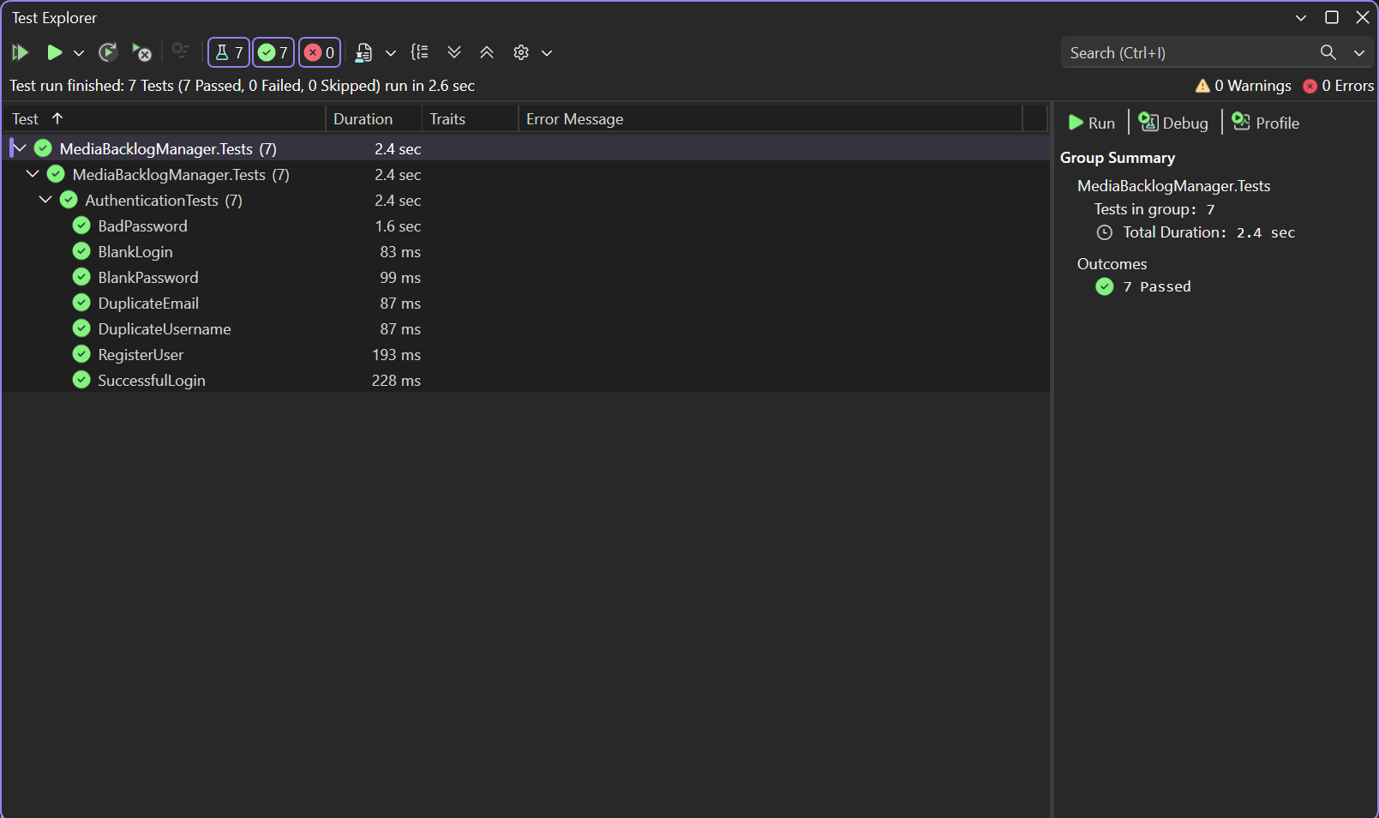

Guide for Setting Up and Maintaining the Application

Local Environment Setup
- Clone the git repository (Link: GitLab Repo)

Backend Setup
- Open MediaBacklogManagerBackend.slnx in Visual Studio
  - The file is located in \backend\MediaBacklogManagerBackend
- Ensure that the proper project is selected
  - MediaBacklogManager.Tests is the xUnit project that is used for running unit tests
  - MediaBacklogManagerBackend is the ASP.NET backend API project.
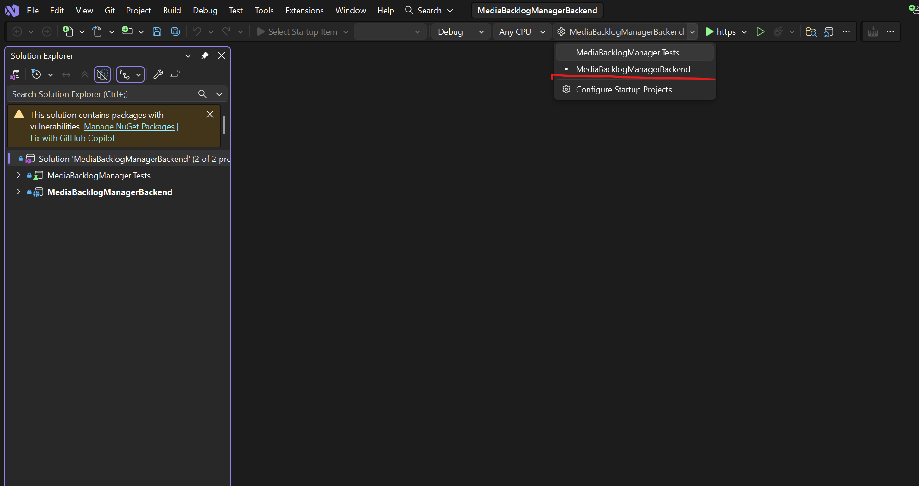
- Press Play to launch the backend.
  - Visual Studio should automatically download and install any necessary NuGet packages, but if it is unable to do so, you can navigate to the \backend\MediaBacklogManagerBackend\MediaBacklogManagerBackend and \backend\MediaBacklogManagerBackend\MediaBacklogManager.Tests folder in PowerShell and run “dotnet restore” to manually download and install the necessary NuGet packages.

Frontend Setup
- The Angular frontend root folder is located at frontend\media-backlog-frontend
- Open this folder in VS Code to load the whole Angular project
- Open the frontend\media-backlog-frontend folder in PowerShell and run “npm install”
  - This will install the necessary node packages for Angular.
- Run “ng build” to build the application or run “ng serve -o” to run the frontend in memory and make real-time changes.

Additional Information
A development account is created by default using the credentials stored in the appsettings.json file in the MediaBacklogManagerBackend project. These credentials can be changed as needed.

Deployment Steps

Frontend Initial Setup.
Create an Azure static web app for the frontend (Create and set up an account if needed)
- Go to the Azure website
- Search for Static Web Apps
- Press Create
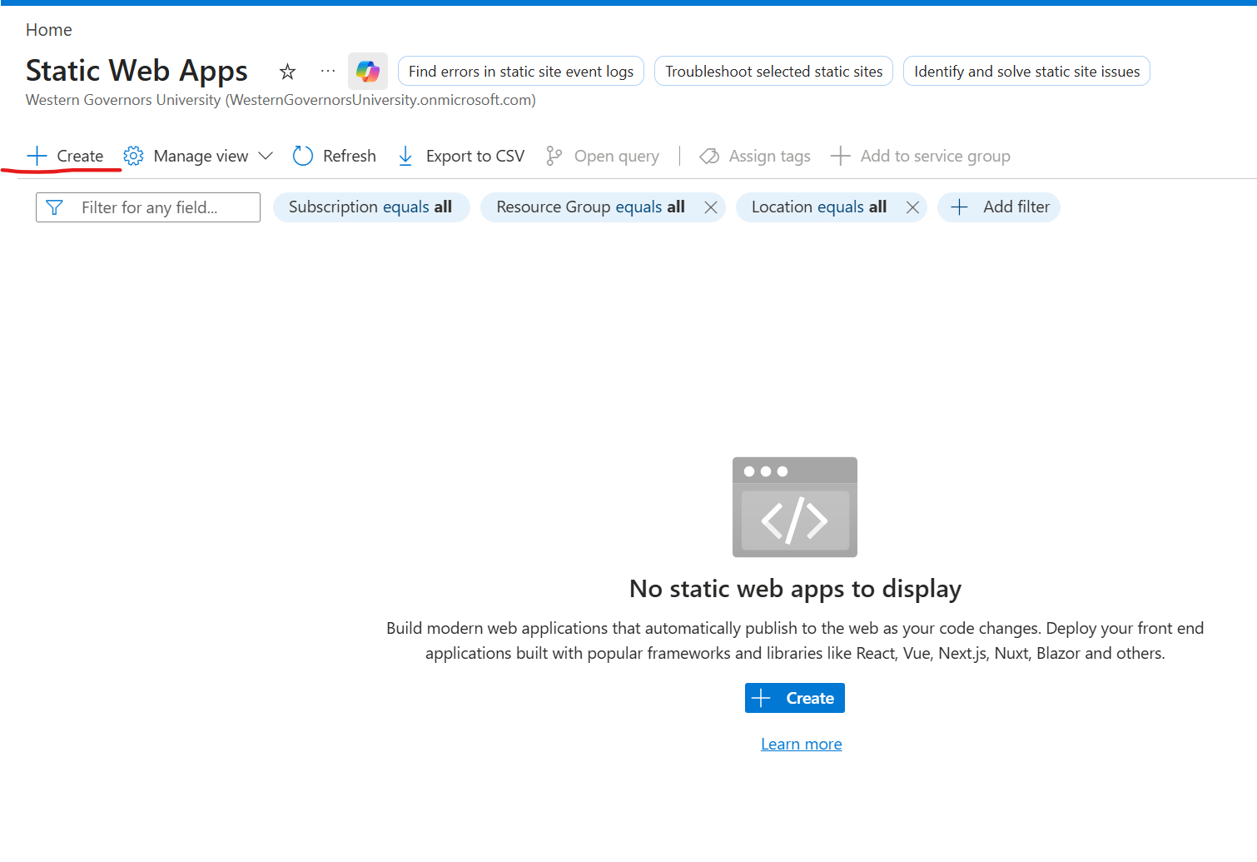
- Select a Subscription, Resource Group, and Name for the static web app
- In hosting options, select Other
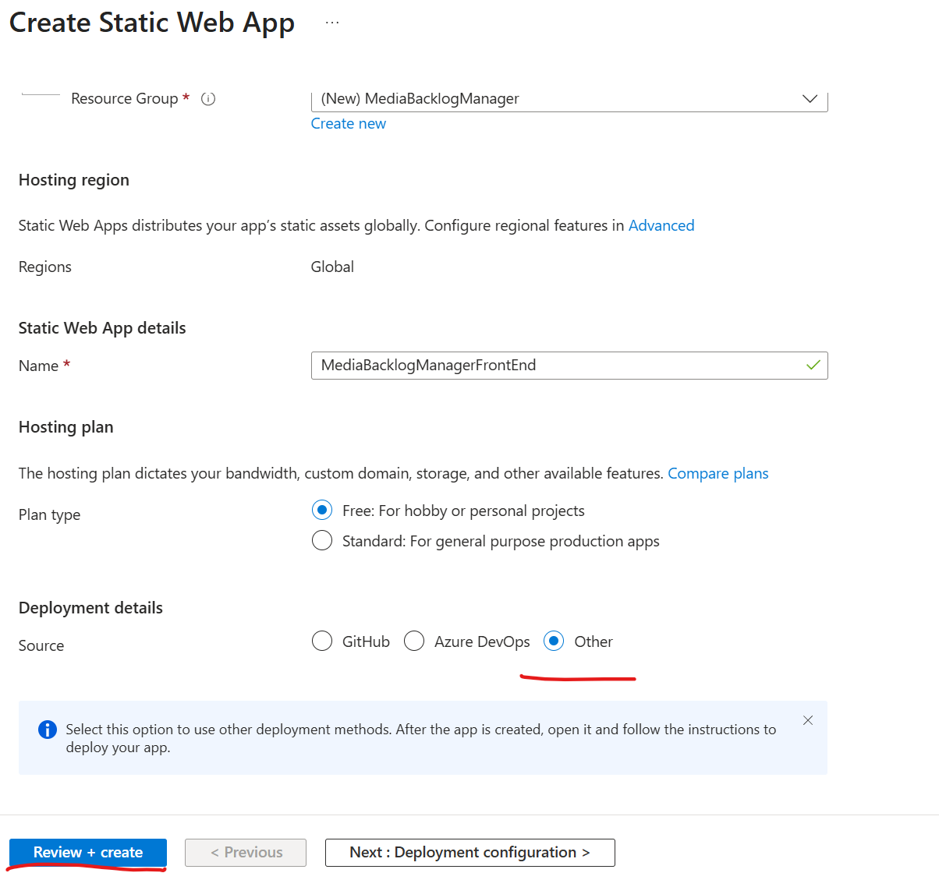
- Press Review and Create
- Wait for the app to be validated (~30 Seconds)
- Press Create
- Once the application has been created, click on Overview > Go to Resource
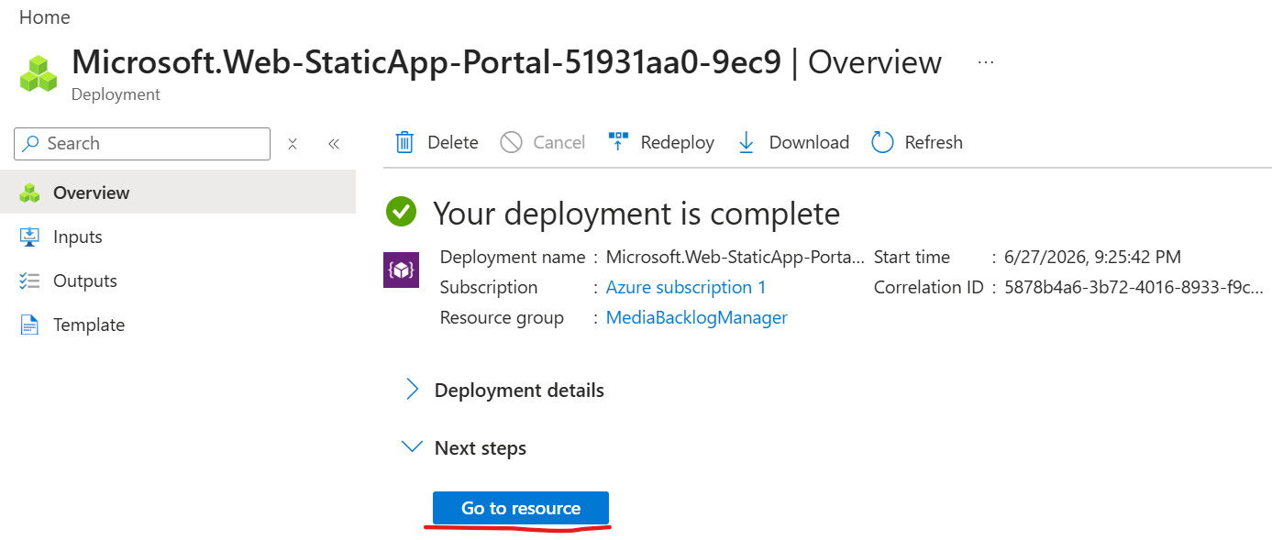
- Click Manage Deployment Token at the top of the page and then copy the deployment token.
- Go to the GitLab repository for the project and then go to settings > CI/CD > Variables
- Set the key as AZURE_STATIC_WEB_APPS_API_TOKEN and then paste the token into the value field
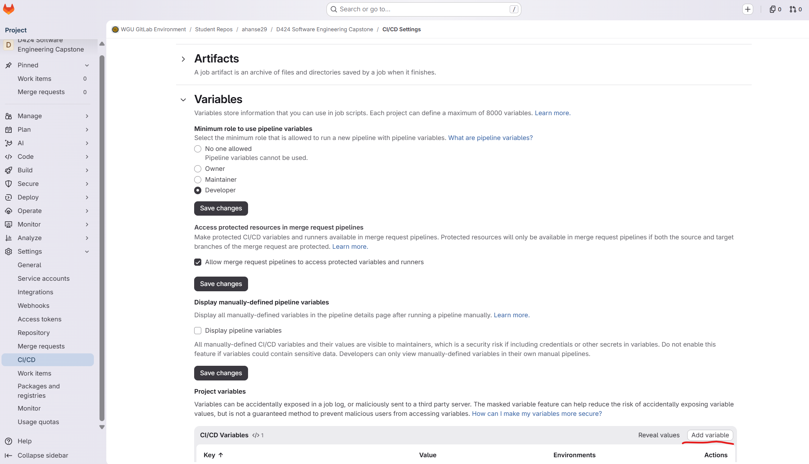
- Hit save.
- Ensure the “.gitlab-ci.yml” file is in the repository root. – This will allow GitLab to connect to Azure and automatically deploy the application.
- Add, Commit, and Push the repository (The repository contains a YML File with the correct commands to deploy the application on the frontend and backend)
- Watch the GitLab pipelines page to ensure that the application is deployed to Azure successfully.
- Open the frontend website. The URL can be found on the Azure website for the web app that you created in step 9

Backend Initial Setup
- Go to the Azure website
- Search for App Services
- Press Create and then select Web App
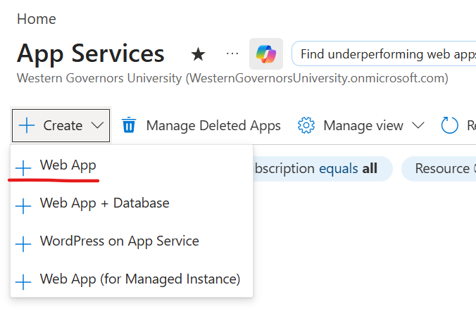
- Select a Subscription, Resource Group, and Name for the static web app
- In the publish field, select Code
- In the runtime stack, select .NET 10 (LTS)
- Select Windows for the operating system.
- Pick a region (I picked East US 2. If you receive an error about a quota, you may need to ensure that you have available VMs in your quota for whichever pricing and location you are using.)
- Select a Windows plan and a pricing plan
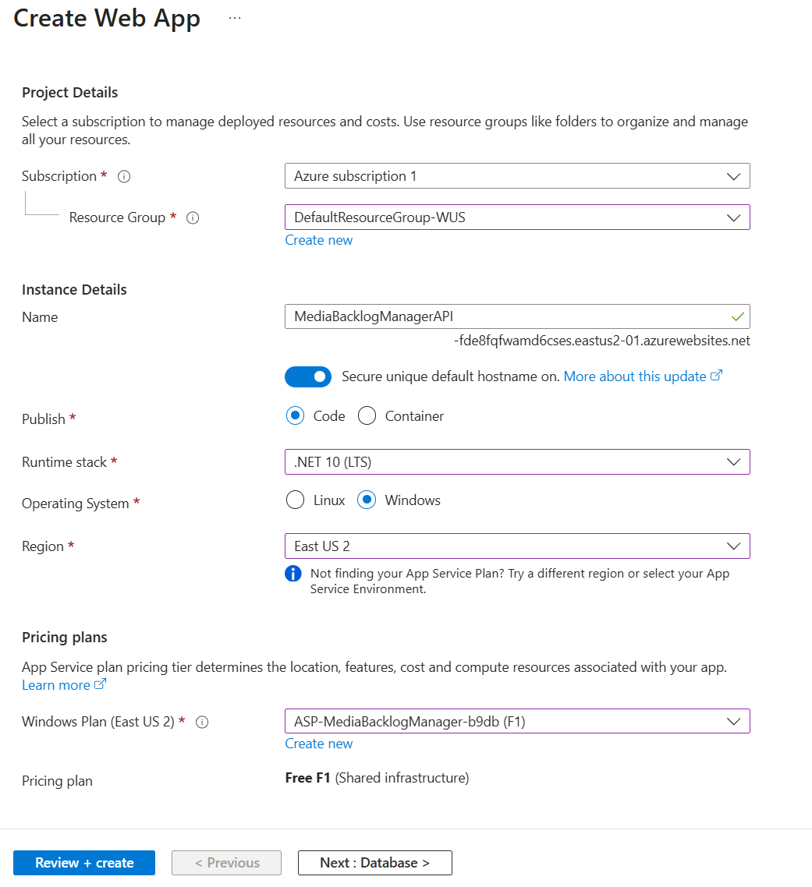
- Press Review and Create
- Review the summary page and Press Create
- Once the application has been created, go to the overview page
- Go to Settings > Configuration > Check the SCM Basic Auth Publishing Credentials box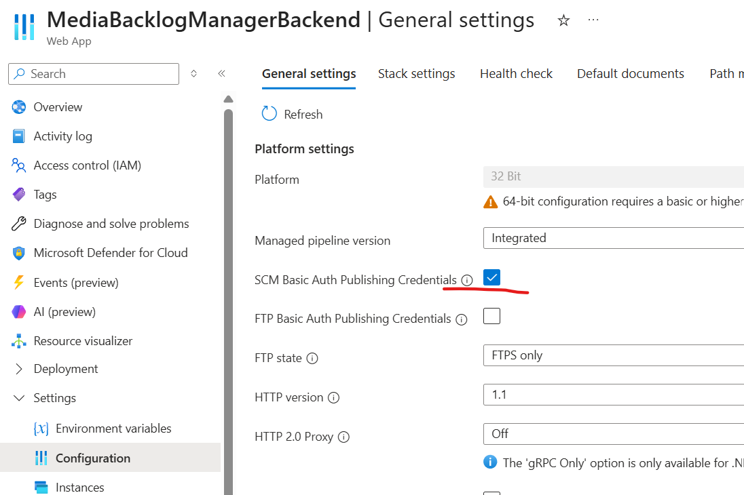

- Press Apply.
- Go back to the overview page and press Download Publish Profile
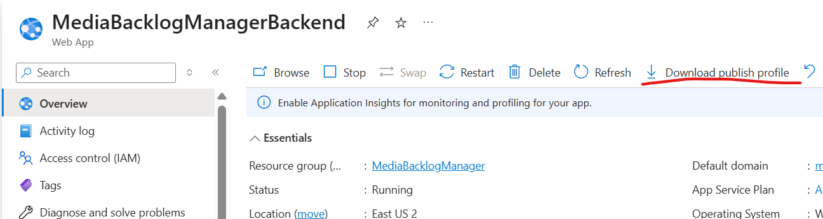
- Set Environment Variables
  - Go to Settings > Environment Variables > App settings
  - Set the following environment variables (Please include the double underscore in the names)
    - Jwt__Key
      - Secret key to identify the server. Set the value to a 32+ digit random string.
    - Jwt__Issuer
      - Used to identify the issuer of the authentication token. Give it a name as its value
    - Jwt__Audience
      - Used to identify the application that uses the authentication token. Give it a name as its value
    - User__Username
    - User__Password
  - Go to the connection string tab and set the following connection string
    - Name: “DefaultConnection”
    - Value: ”D:\home\data\BacklogManager.db”
    - Type: “Custom”
- Go to the GitLab repository for the project and then go to settings > CI/CD > Variables > add Variable
- Change the variable type to file and the visibility to visible
- Key: “AZURE_PUBLISH_PROFILE”
- Value: Paste the contents from the publish profile file that was downloaded in step 15
- Press Save.
- Add, Commit, and Push the repository (The repository contains a YML File with the correct commands to deploy the application on the frontend and backend)
- Watch the GitLab pipelines page to ensure that the application is deployed to Azure successfully.

Final Configuration
- Get the URL for the frontend from the static web app overview page in Azure.
- Get the URL for the backend from the app services overview page in Azure
- Paste the URL from the frontend into the Program.cs file in the ASP.NET project. The URL needs to be placed in the CORS options. Currently around line 75 (This file is located at backend\MediaBacklogManagerBackend\MediaBacklogManagerBackend\Program.cs
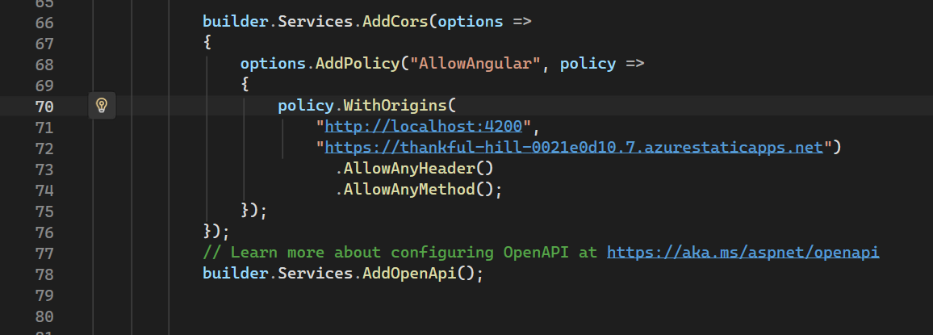
- Paste the URL from the backend into the environment.ts file in the Angular project. This file is located at: frontend/media-backlog-frontend/src/environments/environment.ts. The URL should include /api at the end, as this is the base API endpoint that the application builds its API URLs on.
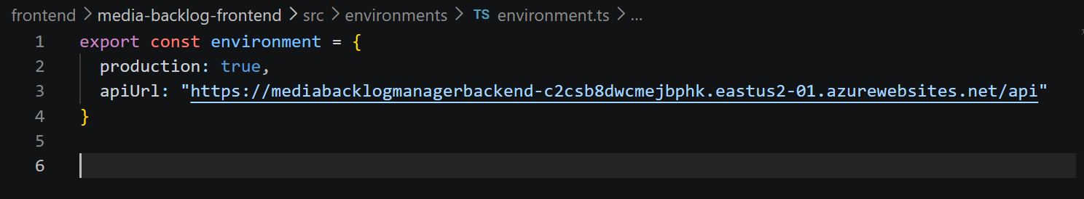
- Once the proper URLs have been added to the frontend and backend, you must run git add, commit, and push to update the repository with the correct information, and to run the deployment pipeline with the new information.
- Watch the pipeline progress in GitLab to ensure that deployment goes smoothly.

User Guide

Introduction
Provided below is documentation for how to use the application. This information is intended to allow a new user of the application to open the application and perform all functions available within the application. Because the application is web-based, no installation is required by the user. The only thing required by the user is to navigate to the webpage where the application is hosted. Due to the application’s web-hosted nature, this information will not cover anything related to the application’s code or deployment. For detailed instructions to modify the code or deploy the application, please see the above guide for setting up and maintaining the application.

Opening the Application
- To open the application, navigate to the application’s web page
https://thankful-hill-0021e0d10.7.azurestaticapps.net/login

Account Creation
- Click on the Create Account button in the bottom right-hand corner of the login screen.
  - The application should automatically route you to this screen
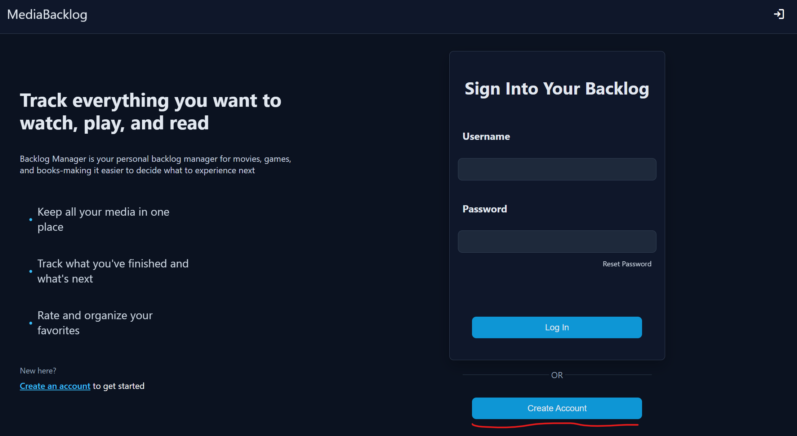
- Enter the following information into the account creation form
  - Display Name – Your Name within the application
  - Email
  - Username – This must be unique. You will be notified if there is a conflict
  - Password – Minimum 8 characters, 1 uppercase, 1 lowercase, 1 number, and 1 special character
  - Confirm your password
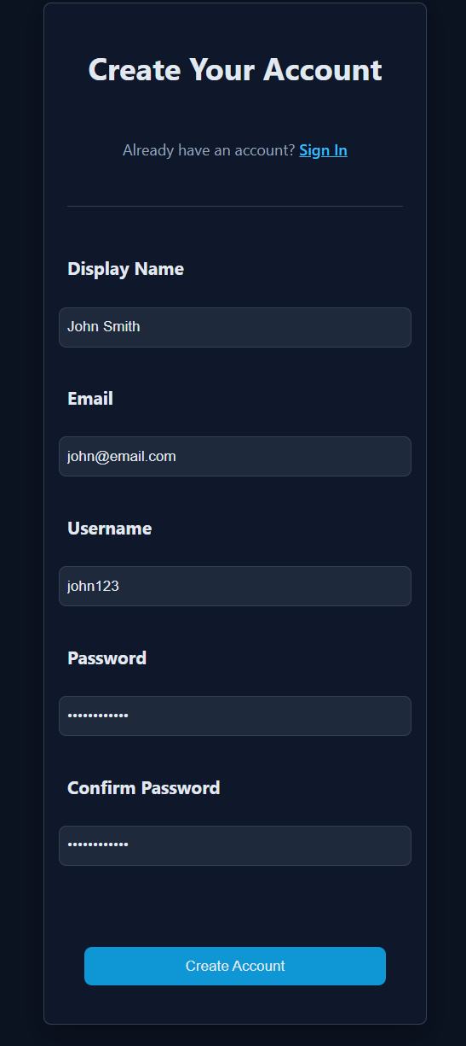
- Press Create Account
  - You will be notified if there are any conflicts with your username, or email or if there are issues with your password.
- You will be redirected to the home screen

Adding an Item to Your Backlog
- To add an item to your backlog, click the add media button in the nav bar, or the one that appears on the home screen.
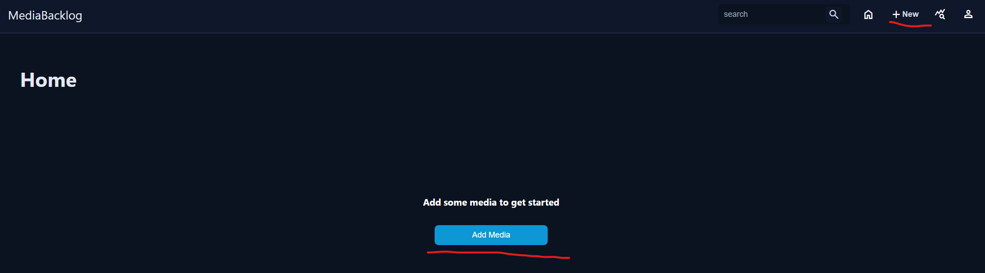
- Begin filling out the Add Media Form
*Please note that only the Title, Media Type, and Date fields are required. While the other fields can be skipped, it will provide you with less information when you view the item and will limit other features of the application.
  - Begin with a title, then select the media type from the dropdown
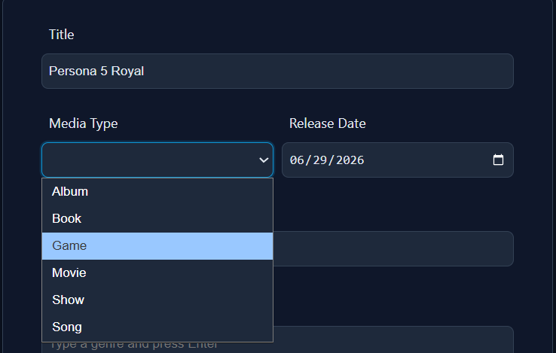
  - Continue by selecting a date and adding a description
  - Add Genres and Recommenders to the item by typing an item, then pressing enter to add it to the list
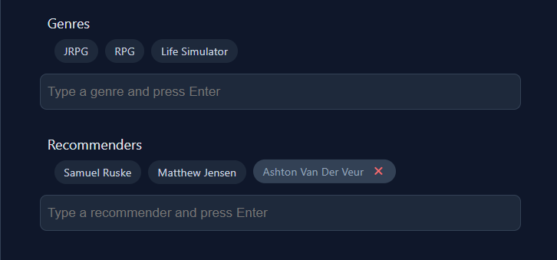
  - To remove a genre or recommender, hover over the entry and press the X button
  - Next, you can enter personal information about the item.
    - Status - A consumption status for the item
      - Backlog – Have not consumed
      - In Progress – Currently in the process of consumption
      - Completed – Have completed the item
    - Prioritize – Allows you to mark an item as a priority item
    - Rating – Allows you to rate a media item
    - Notes – Allows you to leave personal notes regarding an item
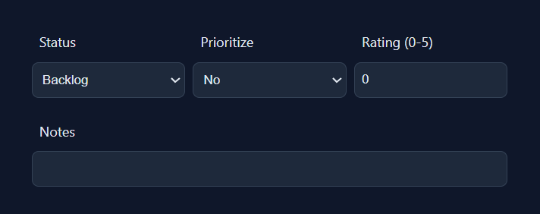
  - Next, you will fill out the remaining fields, which vary based on the media type. Shown below are the fields specific to the game media type.
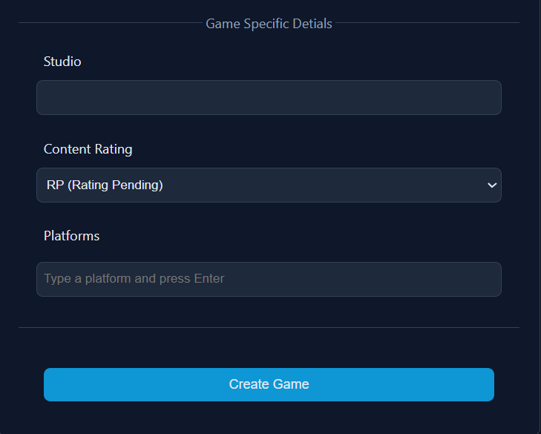
  - Once the form is fully filled out, the item can be created.
- Press the create button
- You will be redirected to the home screen, where your item should now be visible

Viewing a Backlog Item
- To view a backlog item, first navigate to the home screen by clicking the home button in the nav bar, then click on the card of the media item you want to view
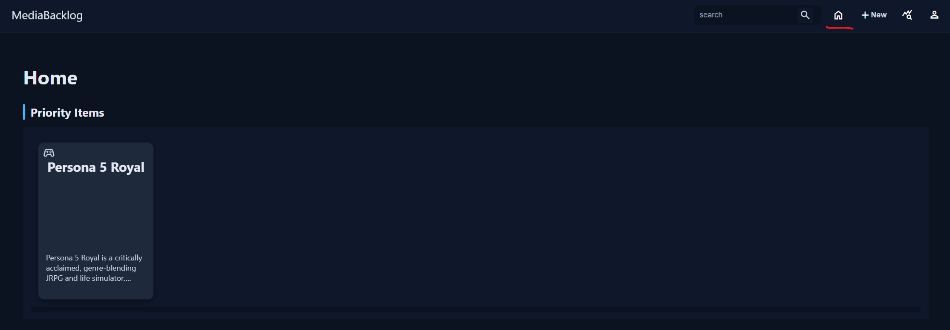
- You will be navigated to the media item view page, which will display the information about the media item.
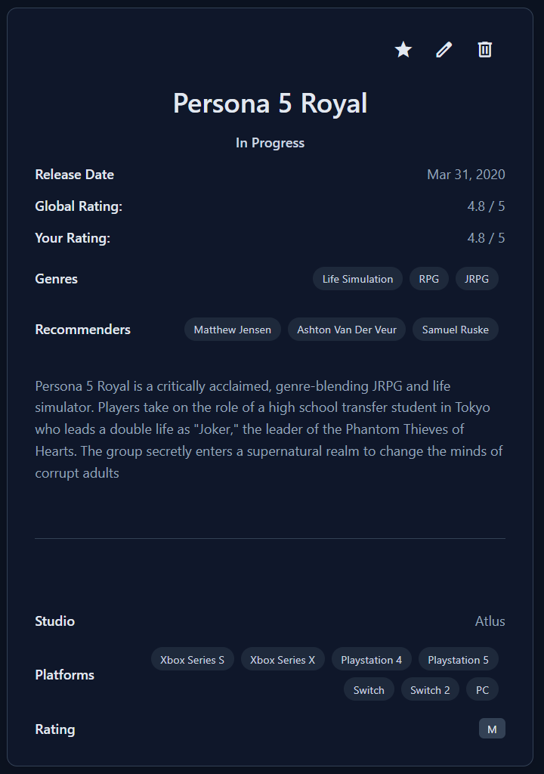

Editing a Backlog Item
- To edit a backlog item, first navigate to the media item view screen as shown previously.
- There are 3 editing options available to edit your media item entry.
  - First, you can quickly toggle the priority status of an item by clicking on the star in the top right corner of the media view card
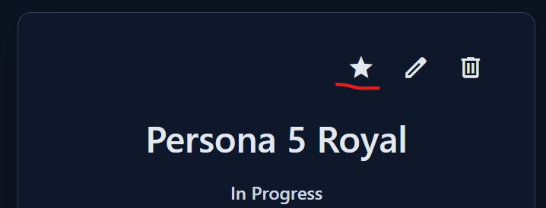
  - Second, you can delete the item by clicking on the trash can icon.
    - You will be asked to confirm if you really want to delete the item
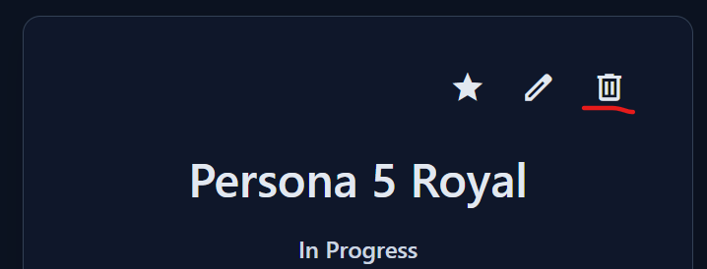
  - Lastly, you can click the pencil to edit all the fields of the item
    - This edit form behaves in the same way as the media creation page. For instructions, please see the “Adding an Item to Your Backlog” section
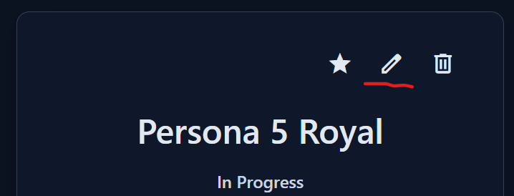

Searching Your Backlog
You can search your backlog in 2 main ways in the application.
- First, you can search at any time by using the search bar available in the nav bar.
  - To use this search bar, enter the term that you would like to search, then press enter or click the search icon.
  - This will display a search results screen where you can see all the items that match your search term.
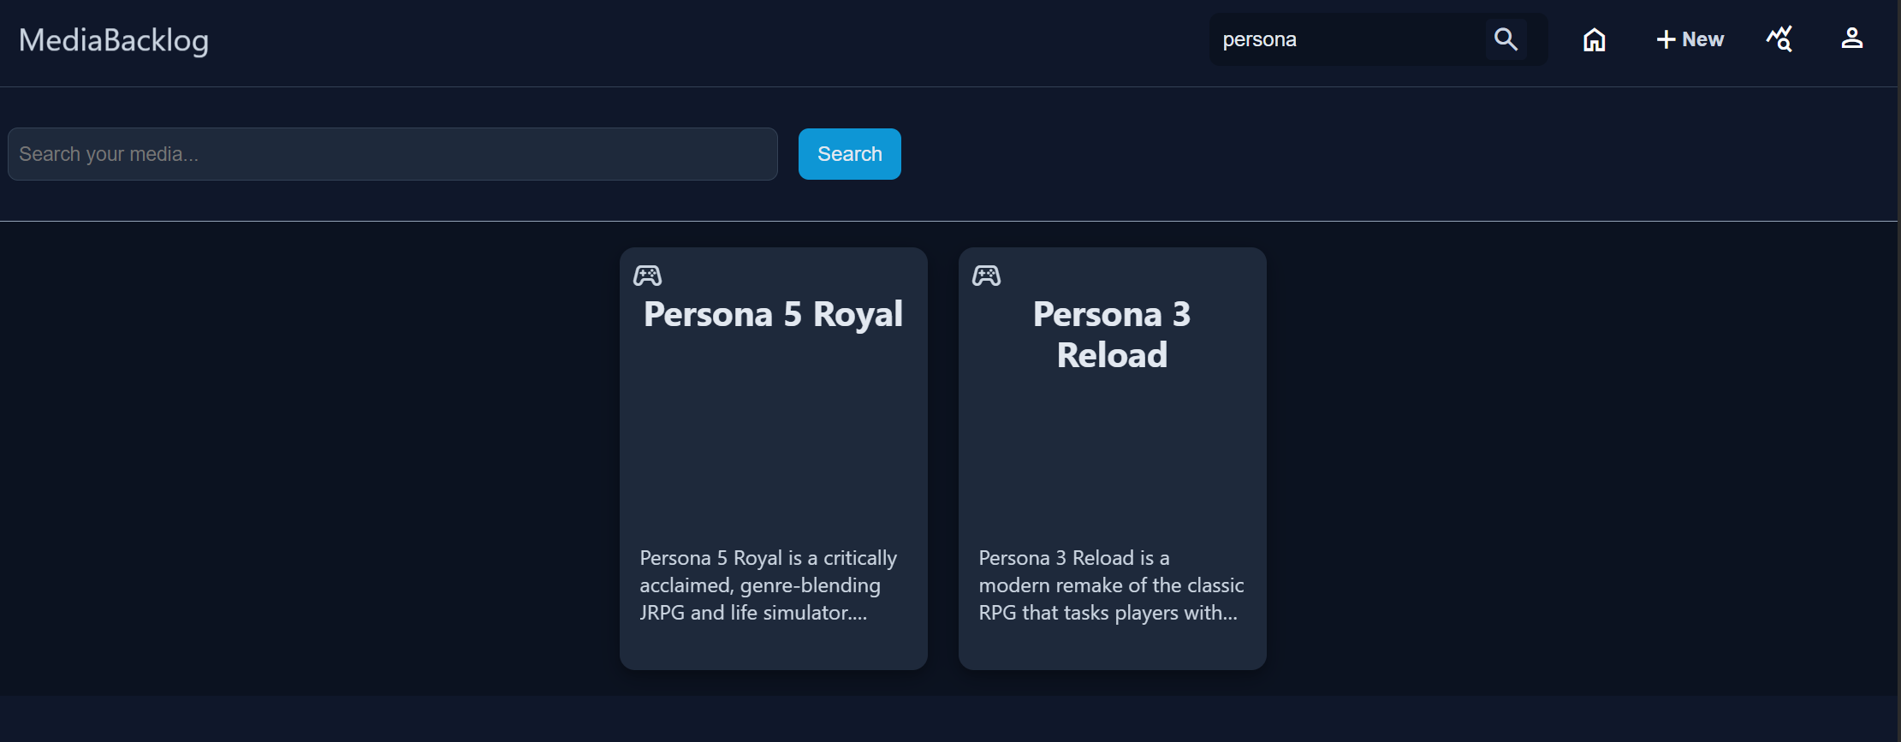
- Second, you can search by clicking on any of the chips on the media view page. This will bring up any media items that share that chip.
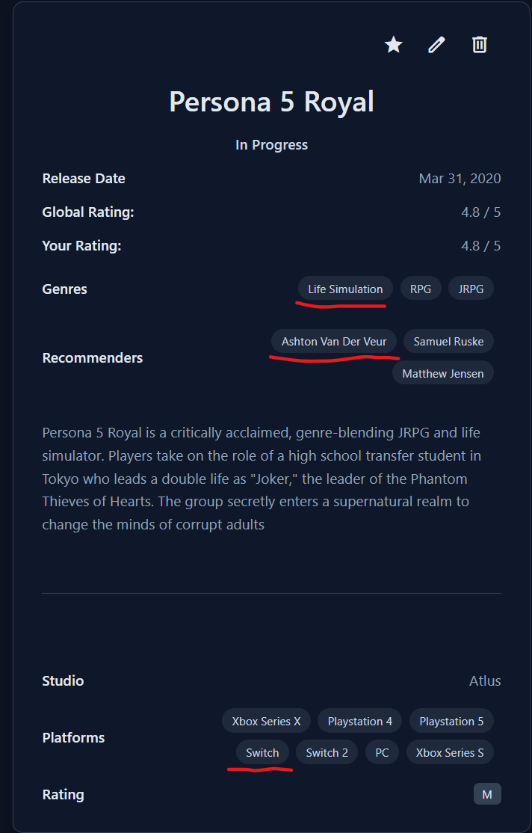
  - There are 3 types of chips in the media view page. Genres, Recommenders, and Platforms. Platforms is a field specific to the game media type that is for listing what gaming platforms the game can be played on.

Viewing Backlog Reports
- To view the auto-generated reports, click on the analytics icon in the nav bar
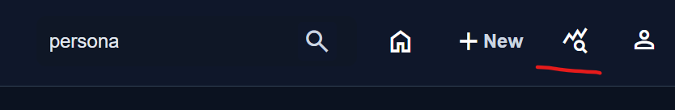
- The analytics page will display 4 different reports generated from the current contents of your Backlog
  - Completed Items – A list of all items that you have completed with add and completion dates
  - Priority items – A list of all items that you have marked as prioritized with an addition date and the number of days that have elapsed
  - Media Type Report – a List of Media Types with information about the total number of items and the number of items in each state
  - Time to Completion – A list of Media Types that shows how long it takes to complete that type of item.
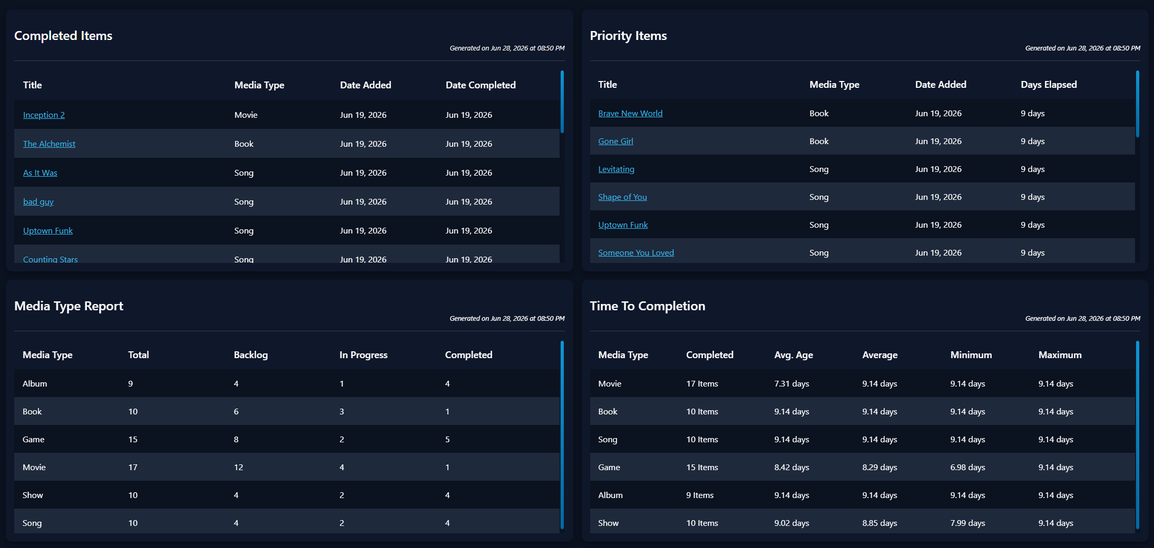

Exporting Your Data
- To export your data, click on the profile button in the top right and then select “Export Data”
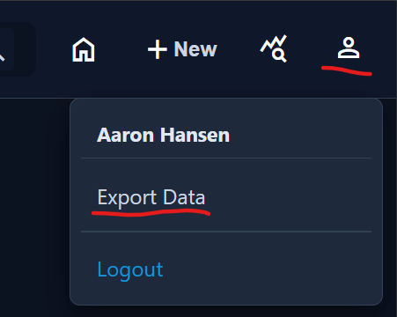
- On the data export page, click on the “Export Data” button
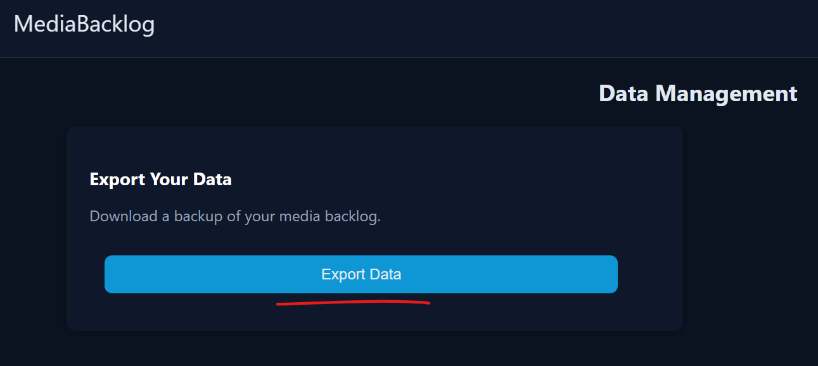
- A JSON file will be downloaded containing your backlog in its entirety.

Logging Out
- To log out of the application, click on the profile button in the top right and then select “Logout”
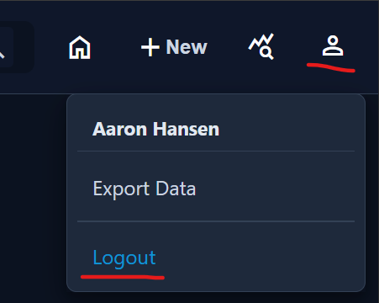
- You will be taken to a page to confirm that you have logged out.

